JOMO KENYATTA UNIVERSITY OF AGRICULTURE AND TECHNOLOGY
INTRODUCTION TO COMPUTER AND DATA PROCESSING
GROUP ASSIGNMENT NAME REGISTRATION NUMBER Alex Maina HSB213-0405/2022 Grayson Anyula HSB213-0070/2022
Derrick Munene HSB213-0406/2022
alex ,gray and derrick
10-30-2023

- This assignment will comprise of
- Inserting images – behind the text and infront of the text
- Inserting water mark
- Inserting 3 columns
- Inserting tables with split and merg
- Alignment of left , right , center and justified
- Numbering-nested numbering and use of bullets
- Inserting a cover page
- Inserting a formulae
- Inserting a header
- Inserting a footer
- Finally posting the work on github

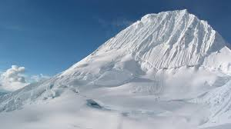
- This new page contains
- Bullets instead of numbering
- An image behind the text


And this image which appears to be infront of the text
The above image seems to be infront of the image

This page will contain a Table with 3 columns and split
NUMBER | NAME | REG NUMBER
1 | Alex | HSB213-0405/2022
2 | Grayson | HSB213-0070/2022
1 | Derrick | HSB213-0406/2022

- The page also contains Binomial Theorem equation
- ${\left(x+a\right)}^{n}=\sum_{k=0}^{n}{\left({n \atop k}\right)x^{k}a^{n-k}}$
- Which is used to determine the roots of equations in higher power

